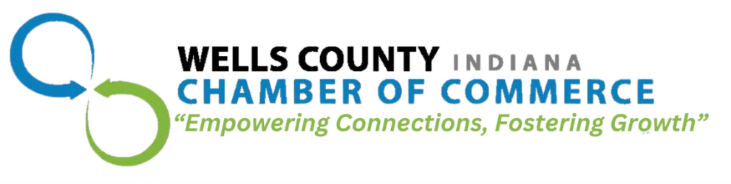
211 Water Street
Bluffton, IN 46714
260.824.0510

Business of the Year Nomination Form

The 112th Wells County Chamber of Commerce Annual Dinner & Awards Ceremony Scheduled for February 23, 2026

When nominating a Wells County business, think about how the business…
- has made an impact on you and many others in the community
- positively contributes to the quality of life in Wells County
- goes above and beyond for their customers

If you would like to submit a nomination, please provide the following information:

Your Name: _____________________________________________________
Your Phone: _____________________________________________________
Your Email: ______________________________________________________
Name of Business you would like to nominate and why you think they are worthy of this honor?
____________________________________________________________________________________________

____________________________________________________________________________________________

____________________________________________________________________________________________

____________________________________________________________________________________________

Support letters and other documents are also encouraged.

Please submit your nomination by November 25, 2025, either by mail or email:
Mail: Erin Prible
Wells County Chamber of Commerce
211 Water Street
Bluffton, IN 46714

Email: eprible@wellscoc.com
Continued:
2011 - AdamsWells Internet
2012 - Troxel Equipment
2013 - National Oil
2014 - Peyton's Northern
2015 - Edge Manufacturing
2016 - United Way of Wells County
2017 - First Bank of Berne
2018 - Alexin
2019 - Ossian Deli
2020 - Outdoor Concepts
2021 – Daniel’s Jewelers
2022 – Wells County Automotive-NAPA
2023 – Trusted Solutions Group
2024 – Valero Renewables
2025 – Meyer Building
Past Business of the Year Award Recipients:
1996 - Almco Steel
1997 - James S. Jackson Co.
1998 - Franklin Electric Co.
1999 - Pretzels, Inc
2000 - Honegger, Ringger & Co.
2001 - Ossian State Bank
2002 - Dale, Huffman & Babcock
2003 - Thoma-Rich, Hewitt & Chaney
2004 - Christian Care Retirement Community & Ossian Health &
Rehabilitation
2005 - Roembke Manufacturing & Design
2006 - Bluffton News-Banner
2007 - Bluffton Regional Medical Center
2008 - General Manufacturing
2009 - Hiday Motors
2010 - Heyerly's Market

